!

,AE>BGB<4=E:8E:4\*.BE532/E-22E7E222E:8F:B+@9E@E)~~;~~<E

7ED;<E618@@4\*E\*E(’((0(&E%FB$:4#E?4=%"

AE˘E(’(D0( E?4=%E:8E:4\*.SE532/E^BGBS=%+E\*@BE

618@@.E:8F8167TE6E(’( 0(flE~~fi~~E\*@BE618@@.E4@:4\*:4SE 641."

dAEV8$4F7BE^G4?G8##.E%FB$:.<E^GB=#B+4\*TE6%G@4\*TE

6%G@~~4~~\*E\*:B%G4F:4SE=B9+B1O:4@+7TE#4=%1BSE

\*61NF8N+~~M~~m ~~i~~ @4=BGl8:7B~~L~~k ~~i~~ ^18:7G%B#.BEGBJ%1O+8+.~~L~~k

~~i~~ +B#8+7FB@64BE^18:7G4\*8:7BE@E%68J8:7B#E

6417FB~~@~~+\*8EF8@4\*E:8E68l=%NE+B#%TEK2VE7EI2VE^4E 68l=4SE+B#B"

AE EG8$4F7<E^G4?G8##8<E^4E6%G@%E\*:B%G4F67E:%l:4

4$9J8+B1O:4E%68J.\*8+OEv4G#%EJ8:9+7S"

AEV8$4F7BE^G4?G8##.E^41:4@+ONEv4G#7G%N+@9E@E

%FB+4#E^G4?G8##.E\*4@^7+8:79TE8E:BE+41O64E

+B#8+7FB~~@~~64BE^18:7G4\*8:7B"

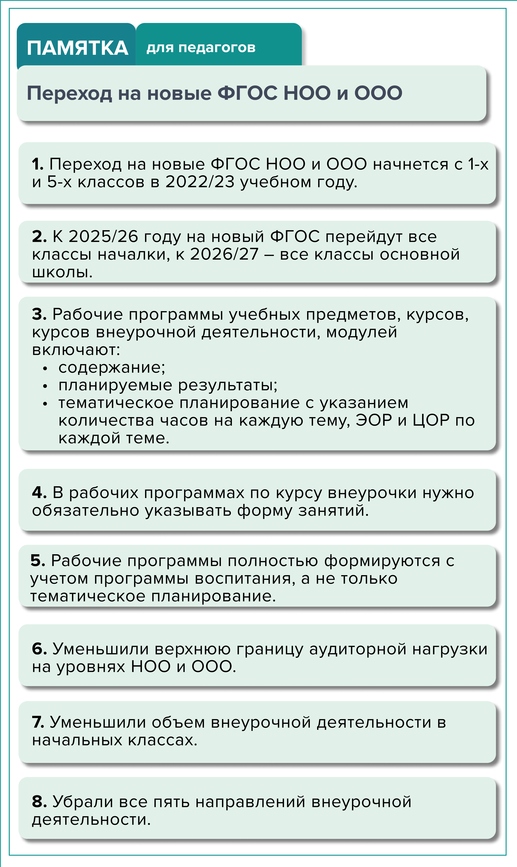§AE¢#B:O 717E\*BG<:NNE?G8:7“%E8%=7+4G:4SE:8?G%J67E :8E%G4\*:9<E-22E7E222"

7AE¢#B:O 717E4$ъB#E\*:B%G4F:4SE=B9+B1O:4@+7E\*E :8F81O:.<E618@@8<"

8AE¢$G817E\*@BE^9+OE:8^G8\*1B:7SE\*:B%G4F:4SE =B9+B1O:4@+7"